QuickFormDiff Utility Readme
2010

Disclaimer

This is a pre-release document. The Technical Preview program provides preview releases of selected Sage SalesLogix products to selected Business Partners and Customers. Those participating in this program agree to install the product and provide feedback to Sage. Users understand that the documentation may be limited and any available documentation is in draft format and is not complete. Sage makes no guarantee as to the accuracy of the documentation and accepts no responsibility for problems arising from its use.

Understanding the QuickFormDiff Utility

The QuickFormDiff.exe simplifies the process of upgrading customized Sage SalesLogix quick forms. This utility allows you to compare two or three projects and display changes to quick forms in a GUI format. Changes are displayed in the following categories: Removes, Moves, Adds, Modifications, and Resources. You can use this information, along with copy and paste functionality, to integrate your customizations into the current Sage SalesLogix version.
Understanding the Upgrade Process Flow
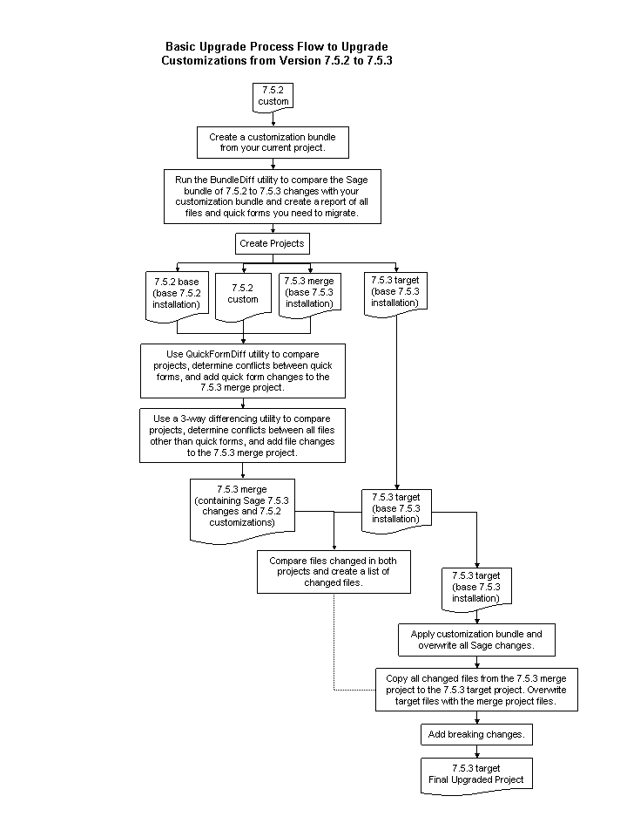

Before You Upgrade

Use the BundleDiff utility (released in version 7.5.2) to determine what files and forms you have customized in your current installation. Run the BundleDiff utility to determine differences between the base Sage SalesLogix version and your customization bundle (for example, slx7.5to7.5.3 changes.zip with 752customizationbundle.zip). Using the BundleDiff output file, record the files that contain conflicts between your customized project and the current Sage project. This report will be used when merging files in a differencing tool and merging forms using the QuickFormDiff utility.

The Upgrade Process

Sage recommends a process of merging customization conflicts in a separate project and then copying merged files back into a clean project. Use the following high-level process, along with the appropriate upgrade document, to upgrade a customized installation.

Note: The following procedures are written as if you are upgrading a customized 7.5.2 environment to 7.5.3.

To upgrade
- IMPORTANT In the Application Architect, back up all projects.
- In the Application Architect, create a customization bundle of your current customized environment.
- Run the BundleDiff utility to create a report of all files and quick forms you need to migrate. See the “Before You Upgrade” section for details.
  - Using BundleDiff, compare the 7.5.2 to 7.5.3 changes bundle and your customization bundle.
  - Run the utility using the “Common” parameter and create an output file of bundle differences. Utility parameters are case-sensitive. For example, “C:\Program Files\SalesLogix>bundlediff /B1:"c:bundle750to752.zip" /B2:"c:bundle7 51to752.zip" /O:"allitems" > c:allitemsout.txt”.

- Create the following projects:
  - 7.5.2 base – A non-customized 7.5.2 project (your current version). Use the Sage SalesLogix 7.5.2 project backup to create the project.
  - 7.5.2 custom – A customized 7.5.2 project (your current version). This project contains the Sage SalesLogix 7.5.2 base version with your customization bundle applied to it.
- Upgrade your environment to 7.5.3. See the appropriate upgrade document for all required tasks.
- Create the following projects:
  - 7.5.3 merge – A base (non-customized) 7.5.3 project. Use the Sage SalesLogix 7.5.3 project backup to create the project. Apply any non-customization bundles or hot fixes currently installed in your environment.
  - 7.5.3 target – A second copy of a base (non-customized) 7.5.3 project. Apply any non-customization bundles or hot fixes currently installed in your environment.
- Use the QuickFormDiff utility to compare the 7.5.2 base, 7.5.2 custom, and 7.5.3 merge projects to find quick form changes. Then, merge your 7.5.2 quick form changes into the 7.5.3 merge project. Use the report generated from the BundleDiff utility to determine the quick forms you need to compare. See the “Using the QuickFormDiff Utility” section for detailed steps.
- Use a 3-way text differencing utility (such as Beyond Compare) and run a File Compare to compare the 7.5.2 base, 7.5.2 custom, and 7.5.3 merge projects and find file changes (all non-quick form conflicts). Then, merge your 7.5.2 custom non-quick form changes into the 7.5.3 merge project. Use the report generated from the BundleDiff utility to determine the files you need to compare.
  - You may want to use the differencing utility to find the changes while the file is open in a text editor (such as Notepad). As you view the changes, you can edit the file in the text editor. When you save the file, overwrite the file in the local folder which also updates the project.
- Use a text differencing utility to create a list of changed files between the 7.5.3 merge and 7.5.3 target projects.
  - The 7.5.3 merge project will contain quick form and non-quick form customizations.
  - The 7.5.3 target project is a base (non-customized) project.
  - When you compare projects, run a “Folder Compare” at the model level. Filter on the changes and compare file sizes.
- Open the 7.5.3 target project. This should be a base (non-customized) 7.5.3 project.
- Apply your customization bundle to the 7.5.3 target project. When prompted, overwrite all Sage information with your customizations.
- Using the list of changed files created in step 9, copy all changed files from the 7.5.3 merge project to the 7.5.3 target project. This overwrites the Sage changes with the files that contain a merge of Sage changes and your customizations.
When doing final project compare you can disregard the following files:
  - model index.xml
  - project info.xml
  - Any files in the deployment folder
- Review any Breaking Changes (changes that affect customizations) and merge them into your 7.5.3 target project. Breaking changes are documented in the appropriate upgrade document. The 7.5.3 target project is now your final upgraded project workspace containing all Sage changes and your customizations.
- Build and deploy your Web sites.

Using the QuickFormDiff Utility

The QuickFormDiff utility is installed in the …\\Program Files\SalesLogix folder. A corresponding configuration file must exist in the same folder as the utility.

The QuickFormDiff utility compares .NET objects, not the quick forms files. This utility is informational only. You cannot make changes to forms within the utility itself. The recommended process is to open the quick form you are upgrading in the Application Architect. Then, use the information in the utility to make the necessary changes to the quick form in the Application Architect. Depending on your level of customizations, you can add the Sage changes to your custom form or add your customizations to the Sage form.

Note: The following procedures are written as if you are upgrading a customized 7.5.2 environment to 7.5.3 and are following the steps in “The Upgrade Process” section.

To use
- Verify the configuration file exists in the QuickFormDiff installation folder (generally …\\Program Files\SalesLogix).
  - The name of the configuration file is QuickFormDiff.exe.config.
  - Verify the assemblies needed for the utility are installed on your computer.
  - Verify a probing path exists in the configuration file using the following structure: <probing privatePath=“SalesLogix;Platform;SupportFiles”/>
- Double-click QuickFormDiff.exe.
- In the Compare a QuickForm dialog box, set the following fields, and then click Analyze.
  - Base SLX Project Path – set to the extracted base project backup file (for example, 7.5.2 base).
  - Customized Project Path – set to the extracted project file you created of your customizations (for example, 7.5.2 custom).
  - Current SLX Project Path – set to the extracted base project of your current version (for example, 7.5.3 merge).
  - QuickForm Path – set to the location of the quick form you are comparing. Use the report generated from the BundleDiff utility to determine the quick forms you need to compare. For example, …\Entity Model\SalesLogix Application Entities\Account\AccountDetails.main.quickform.xml. This field can be set to a *.quickform.xml file in any of the projects you are comparing.
- Open the project in Application Architect where you want to merge your customizations with Sage changes (for example, 7.5.3 merge).
- Open the current version of the quick form you selected in step 3 (for example, AccountDetails.main.quickform.xml v7.5.3).
- Use the following tabs as you add, remove, and modify the controls in the quick form. You can copy and paste from the Forms tabs in the utility to the form in the Application Architect or use the information in the utility to manually recreate the customizations in the 7.5.3 merge project.
Note: When using copy/paste of one or multiple controls from the QuickFormDiff utility to the Application Architect, the paste contains everything with the control(s): the control, the properties, and any C# snippet action items. Code snippet action items are not included in the paste and must be merged separately.
  - Base To Custom Changes – Displays the differences found in the selected quick form between the base project (7.5.2 base) and your customized version (7.5.2 custom). This is the tab used to drive the upgrade process. You will use this information to see what customizations need to be reintegrated into the current quick form version.
You can use this tab to get the added properties for new form controls and integrate them into the form in the Application Architect using various collection editors.
  - Base To Current SLX Changes – displays the changes Sage made to the quick form between the base project (7.5.2 base) and the current project (7.5.2 merge).
  - Base SLX Form – displays a GUI version of the selected quick form in the base project (7.5.2 base).
  - Custom Form - displays a GUI version of the selected quick form in the customized project (7.5.2 custom). When copying controls, use this tab to copy the custom control to the associated form in the 7.5.3 merge project in Application Architect.
  - Current SLX Form – displays a GUI version of the selected quick form in the current project (7.5.3 merge).
  - All Base Form Properties – displays a list of the controls and their properties in the base version of the selected quick form (7.5.2 base).
  - All Custom Form Properties – displays a list of the controls and their properties in the custom version of the selected quick form (7.5.2 custom).
  - All Current SLX Form Properties – displays a list of the controls and their properties in the current version of the selected quick form (7.5.3 merge).
- Click the Base To Custom Changes tab.
- Use the Removes, Moves, Adds, Modifications, and Resources tabs at the bottom of the tab to reintegrate your customizations. Use the tabs in the order they appear from left to right. When reviewing changes:
- Disregard changes that only appear in the 7.5.3 merge project.
- Remove code that was removed from the 7.5.2 custom project that still exists in the 7.5.3 merge project.
  - Do not leave resource files open when you are working on the associated quick form in the Application Architect.
Every quick form has an associated resource file that must be updated for your customizations. Any text that displays to the user is stored in the resource files. Localization changes must be made in the resource files.
Note: In the files, row and column numbers are zero based.
This is the recommended path to integrate customizations:
  - Removes – use to remove any controls that have been removed from the form. This tab includes controls with properties that had their values removed. You may also see information about forms that may have been renamed. A control’s identity is recorded by its control ID and not the form name. If you rename a control, it appears as if the control was removed and a new control added. The utility logically looks at the Adds and Removes and suggests the possibility that the control was renamed.
  - Moves – use to find the controls that have been moved to a new location on the form.
  - Adds – use to see the controls that have been added to the form. To use this tab you might 1) View the changes on the tab. 2) Switch to the Custom Form tab and copy the new control. 3) Paste the control into the form you have open in the Application Architect. You can copy/paste multiple contiguous controls simultaneously. If there is a gap between controls, you should perform multiple copies.
Note: When copying controls, resource files are not copied. Resources are integrated using the Resources tab.
  - Modifications – use to see the old value and new value of controls that have been modified.
  - Resources – compares form objects and displays the resources associated with the quick form that have been added, modified, or removed.
- Use the Copy All button to copy all added resources to a new resource file. The new file is saved to the same folder as the resource file with a modified name. For example, C:\SP3Project\Model\Entity Model\SalesLogix Application Entities\Account\QuickForms\ AccountDetails.main.quickform.xml.resx.new.resx.
- Review the new resource file.
- Delete the previous resx file and remove “new.resx” from the new resource file name.
- Restart the Application Architect. Resources are cached outside the project and a restart refreshes the project information.

